At Nutanix, we proudly uphold our core values, commonly referred to as ‘the four H’s’: Hungry, Humble, Honest, with Heart



public class Solution {

public static long calculateTotalRegion(int[] h) {

int n = h.length;

long[] l = new long[n];

long[] r = new long[n];

for (int i = 1; i < n; i++) {

int j = i - 1;

while (j >= 0 && h[j] <= h[i]) {

l[i] += l[j];

j -= l[j];

}

}

for (int i = n - 2; i >= 0; i--) {

int j = i + 1;

while (j < n && h[j] <= h[i]) {

r[i] += r[j];

j += r[j];

}

}

long t = 0;

for (int i = 0; i < n; i++) {

t += l[i] + r[i] - 1;

}

return t;

} BNY 1

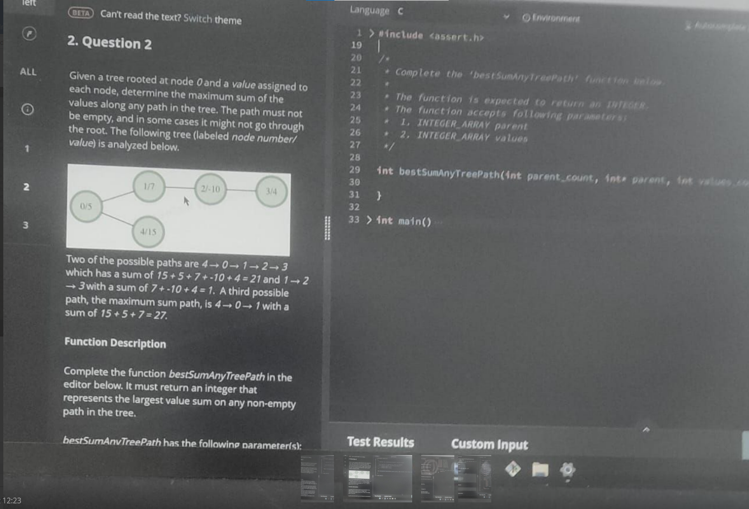

long long result = 0;

// Helper function to calculate

// the maximum path sum using DFS

long long findMaximumPathSum(int currentNode,

                        int previousNode,

                        const vector<vector<int>> &adj,

                        const vector<int> &A)

{

    // Nodes to which currentNode is

    // connected to

    const vector<int> &v = adj[currentNode];

    int maximumBranchSum1 = 0;

    int maximumBranchSum2 = 0;

    for (auto vtx : v) {

        // checking whether the branch is

        // visited already

        if (vtx == previousNode) {

            continue;

        }

        long long bs = findMaximumPathSum(vtx, currentNode,

                           adj, A);

        // Storing the maximum of value of

        // branch path sums

        // maximumBranchSum1 will store the

        // maximum value

        // maximumBranchSum2 will store the

        // 2nd most maximum value

        if (bs >= maximumBranchSum1) {

            maximumBranchSum2 = maximumBranchSum1;

            maximumBranchSum1 = bs;

        }

        else {

            maximumBranchSum2

                = max(maximumBranchSum2, bs);

        }

    }

    result = max(result,

                 A[currentNode] + maximumBranchSum1

                     + maximumBranchSum2);

    // updating the value of current value

    // with maximum path sum including

    // currentNode

    return A[currentNode] + maximumBranchSum1;

}

long long bestSumAnyTreePath(vector<int>& parents, vector<int>& values) {

    int n = parents.size();

    vector<vector<int>> mp(n);

    for (int i = 0; i < n; i++) {

        if (parents[i] != -1) {

            mp[parents[i]].push_back(i);

        }

    }

    result = 0;

    findMaximumSumPath(0, -1, mp, values);

    return result;

}

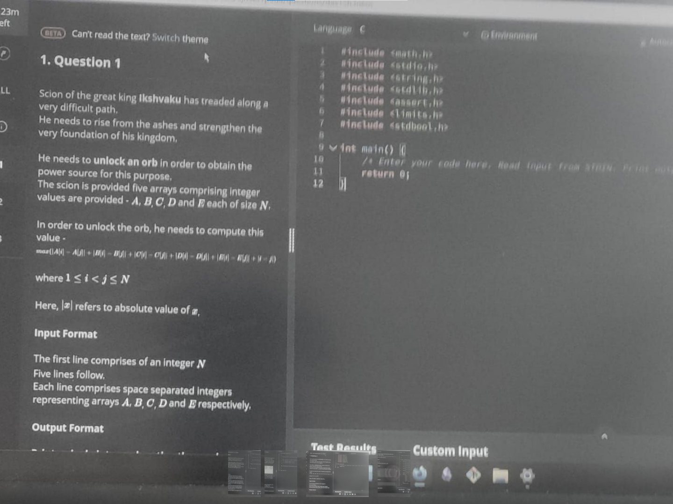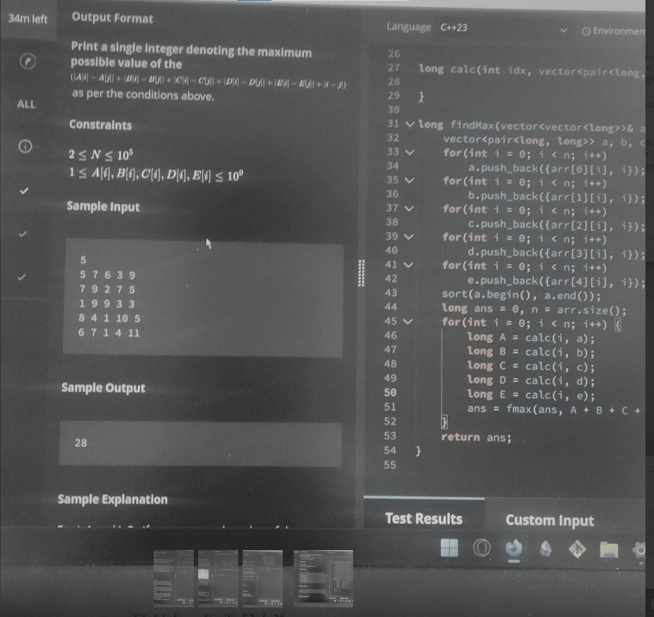

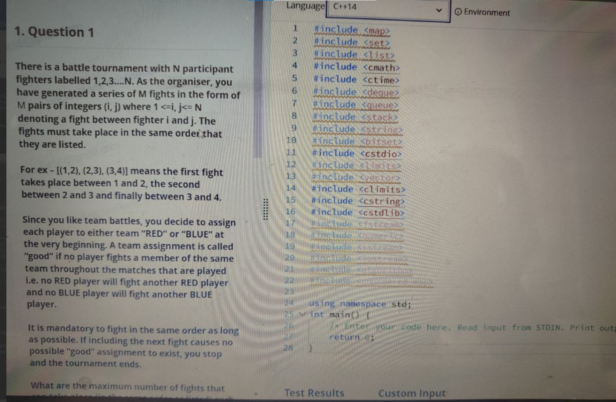

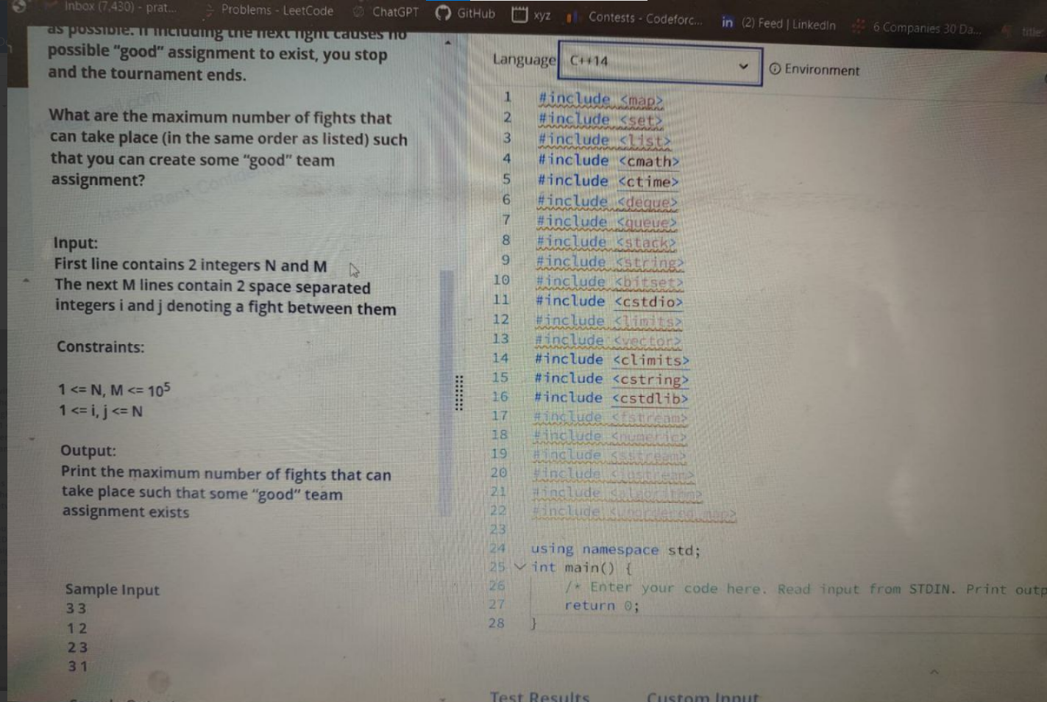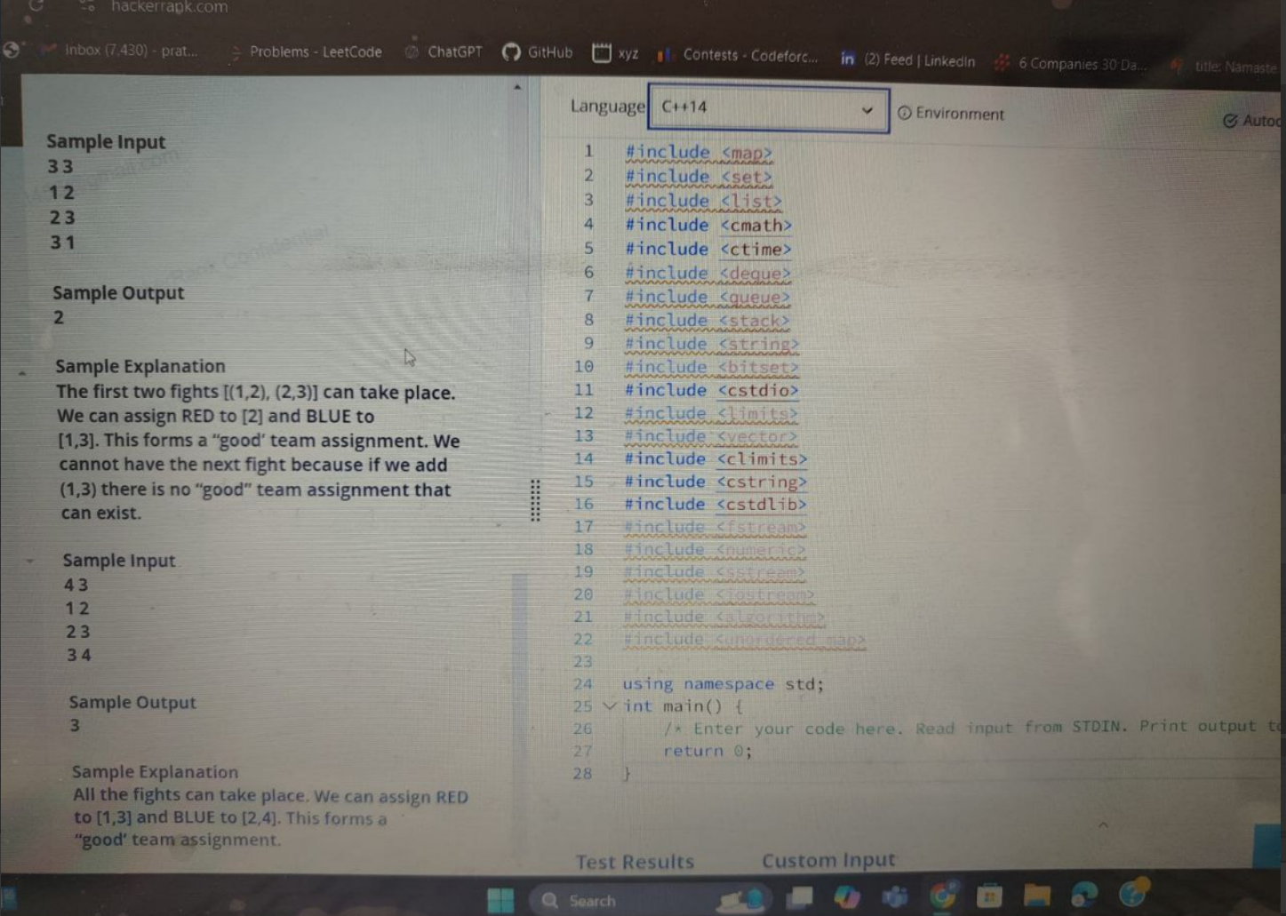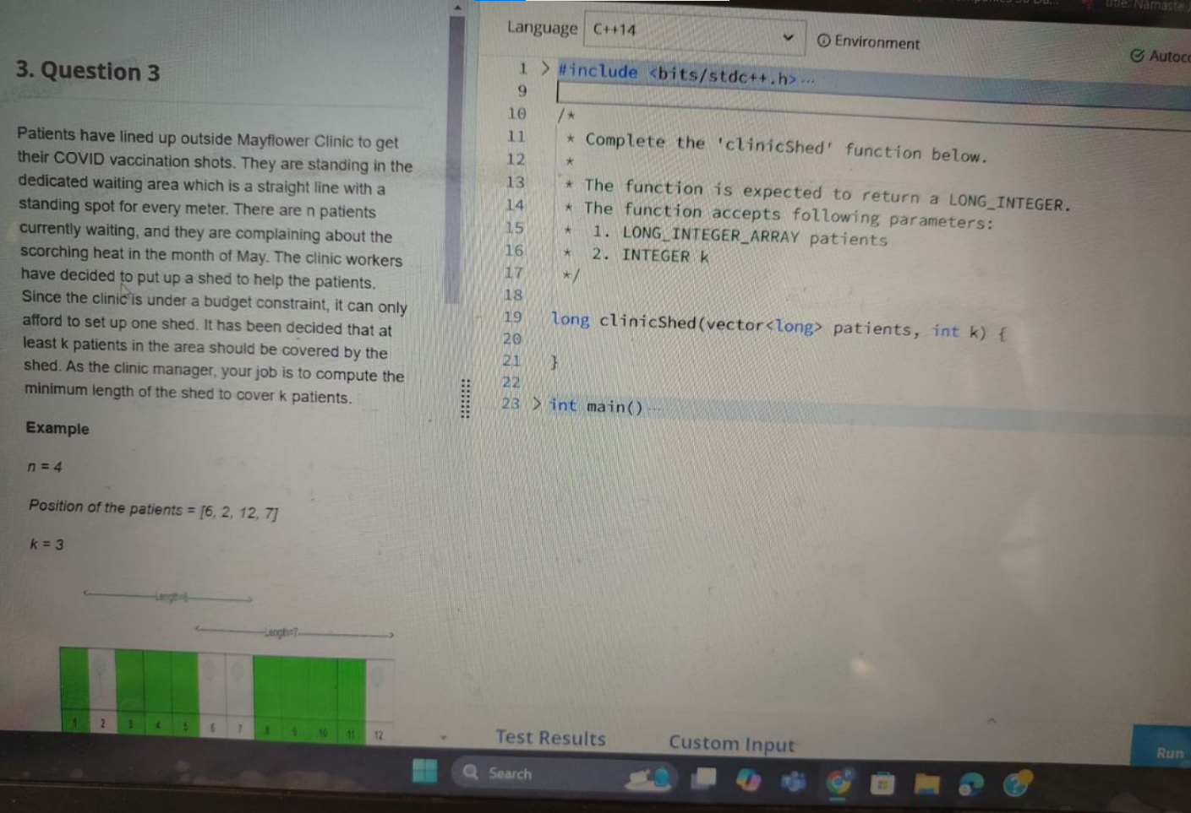

#include <iostream>

#include <vector>

#include <algorithm>

#include <climits>

using namespace std;

long clinicShed(vector<long> patients, int k) {

sort(patients.begin(), patients.end());

long minShedLength = LONG_MAX;

int n = patients.size();

for (int start = 0; start <= n - k; ++start) {

int end = start + k - 1;

long length = patients[end] - patients[start] + 1;

minShedLength = min(minShedLength, length);

}

return minShedLength;

}. GOLDMAN

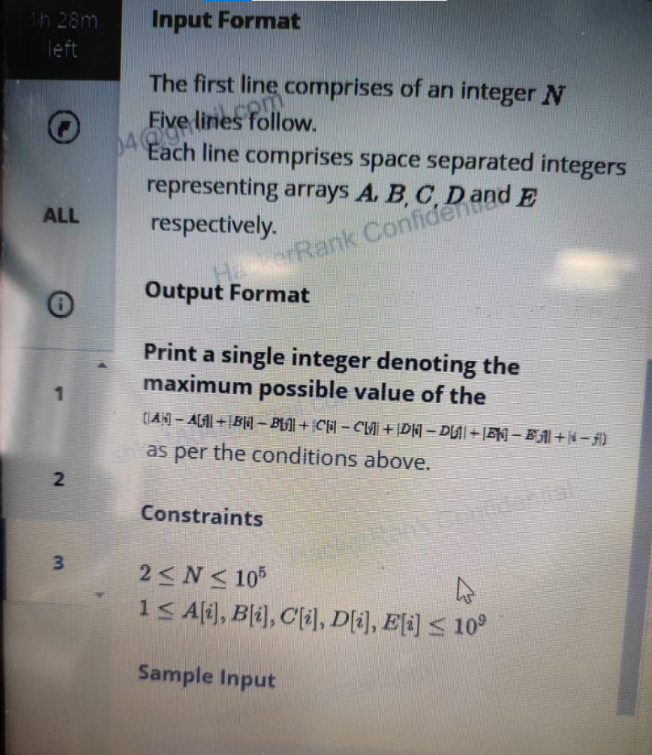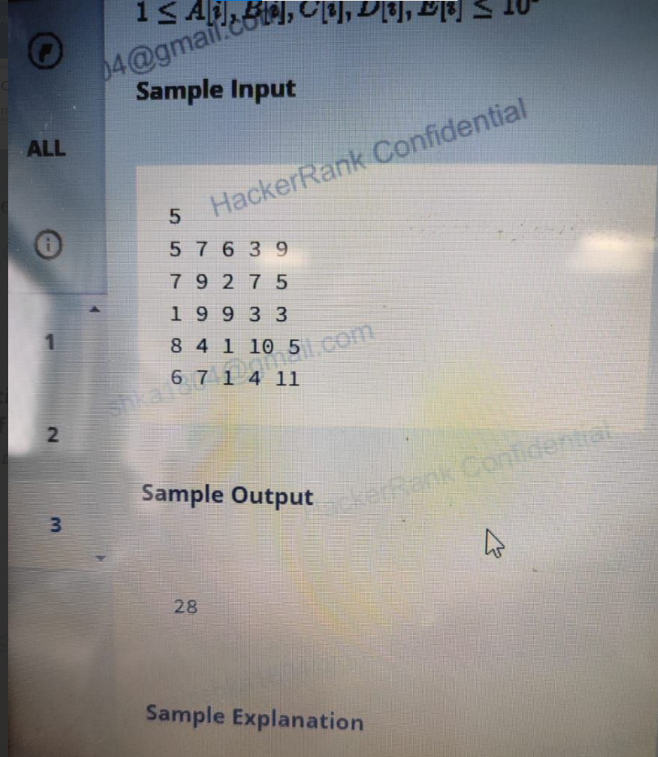

def maxOrbValue(n, A, B, C, D, E):

maxV = -float('inf')

for mask in range(64):

s = [(1 if mask & (1 << k) else -1) for k in range(6)]

minF = float('inf')

for i in range(n):

val = s[0]*A[i] + s[1]*B[i] + s[2]*C[i] + s[3]*D[i] + s[4]*E[i] + s[5]*(i + 1)

if i > 0:

maxV = max(maxV, val - minF)

minF = min(minF, val)

return maxV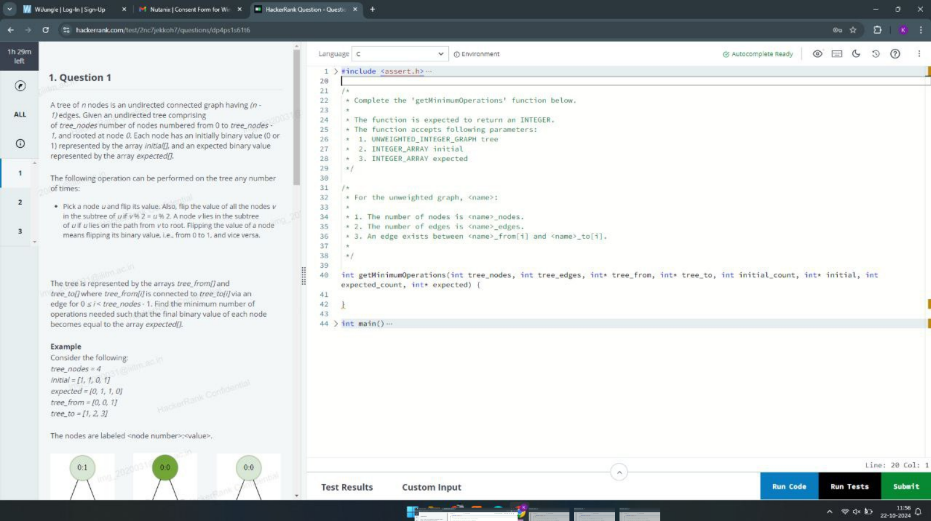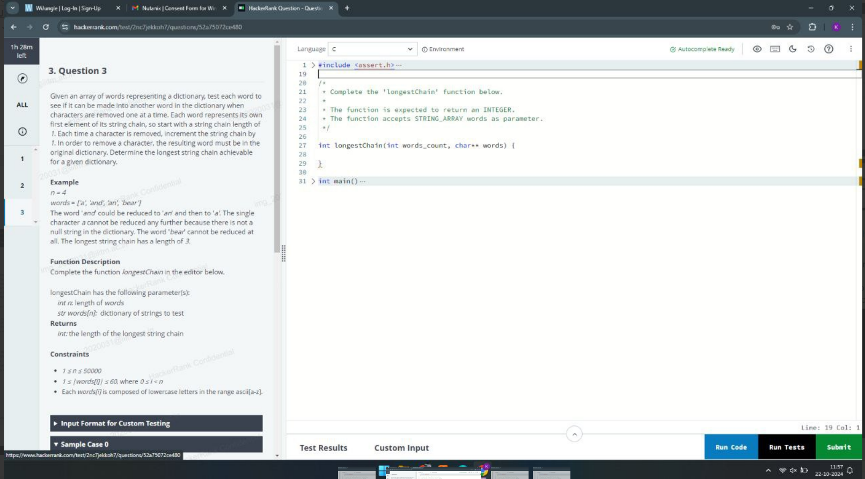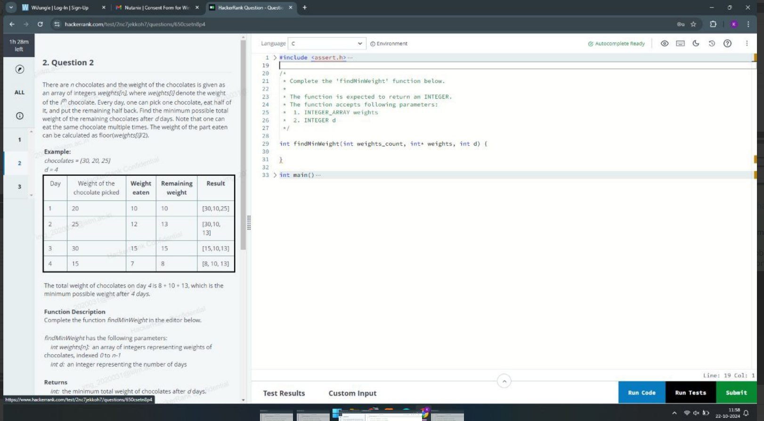int findMinWeight(vector<int> weights, int d) {

priority_queue<int> maxHeap(weights.begin(), weights.end());

for (int i = 0; i < d; ++i) {

int maxWeight = maxHeap.top();

maxHeap.pop();

int remainingWeight = maxWeight / 2;

maxHeap.push(maxWeight - remainingWeight);

}

int totalWeight = 0;

while (!maxHeap.empty()) {

totalWeight += maxHeap.top();

maxHeap.pop();

}

return totalWeight;

}